# CS 255 System Design Document

## UML Diagrams

### UML Use Case Diagram

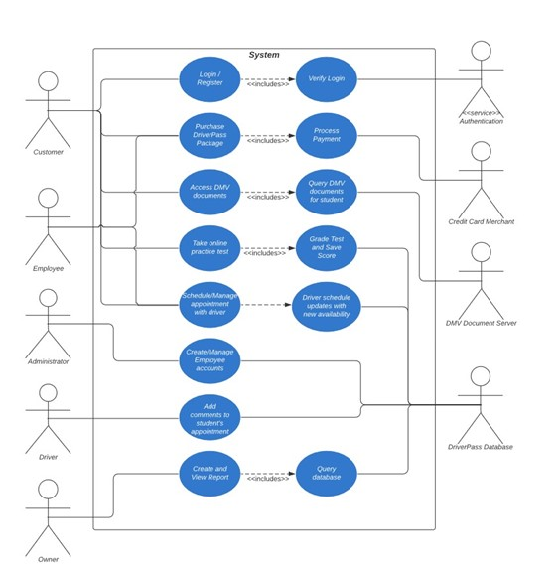

### UML Activity Diagrams

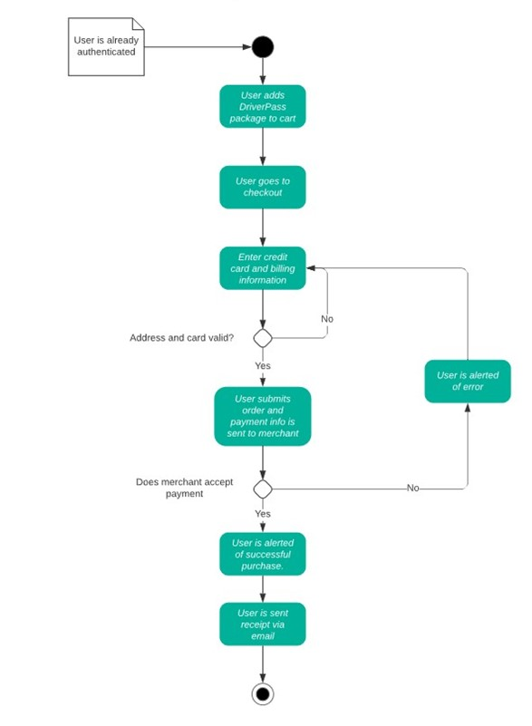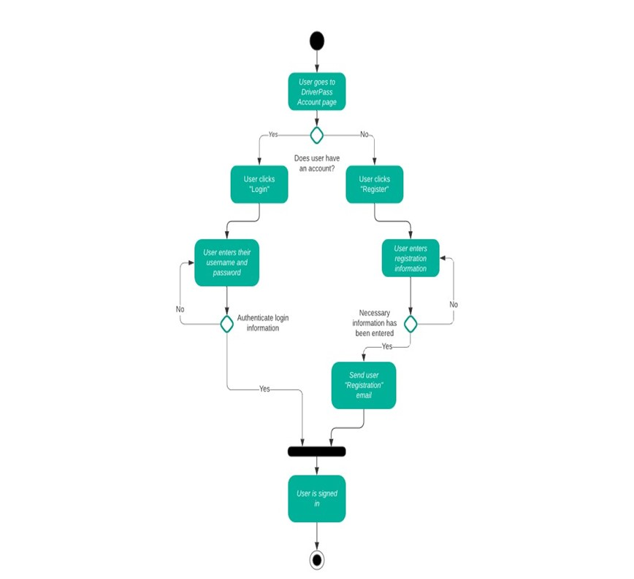

### UML Sequence Diagram

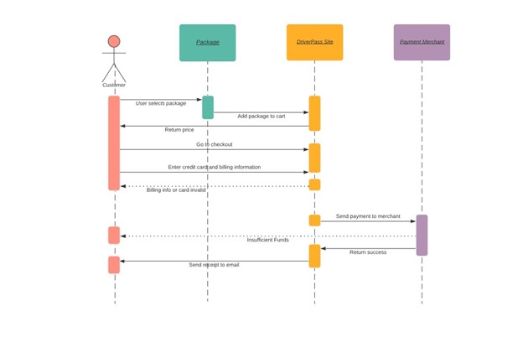

### UML Class Diagram

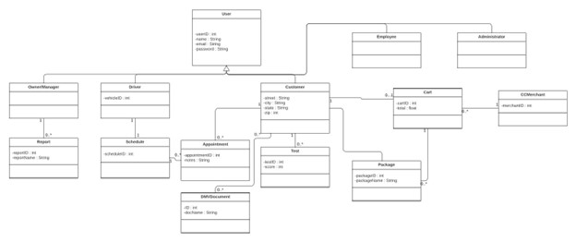

## Technical Requirements

* Hardware
  + Dedicated Server
  + Internet connection
  + Storage for database and website data
  + Computer or mobile device for user to access website
  + A firewall to protect website ports
* Software
  + Windows Server (recommended), most stable release
  + SQL Server for database (recommended), most stable release
  + Backup software for website and database
  + A web server like Apache or Azure
  + Security software to prevent malware
* Geographic Information
  + Website should be accessible in the USA
  + Server for website and database is secured in datacenter
  + Server should be in a central location